Handouts of Lecture 2
Why Fostering Good Business Ethics Is Important
Organizations have at least five good reasons for pursuing CSR goals and for promoting a work environment in which employees are encouraged to act ethically when making business decisions:
- Gaining the goodwill of the community
- Creating an organization that operates consistently
- Fostering good business practices
- Protecting the organization and its employees from legal action
- Avoiding unfavorable publicity
Gaining the Goodwill of the Community
Although organizations exist primarily to earn profits or provide services to customers, they also have some fundamental responsibilities to society. As discussed in the previous section, companies often declare these responsibilities in specific CSR goals. Companies may also issue a formal statement of their company’s values, principles, or beliefs. See Figure 1-1 for an example of a statement of values.
All successful organizations, including technology firms, recognize that they must attract and maintain loyal customers. Philanthropy is one way in which an organization can demonstrate its values in action and make a positive connection with its stakeholders. (A stakeholder is someone who stands to gain or lose, depending on how a situation is resolved.) As a result, many organizations initiate or support socially responsible activities, which may include making contributions to charitable organizations and nonprofit institutions, providing benefits for employees in excess of any legal requirements, and devoting organizational resources to initiatives that are more socially desirable than profitable. The goodwill that CSR activities generate can make it easier for corporations to conduct their business. For example, a company known for treating its employees well will find it easier to compete for the best job candidates. On the other hand, companies viewed as harmful to their community may suffer a disadvantage. For example, a corporation that pollutes the environment may find that adverse publicity reduces sales, impedes relationships with some business partners, and attracts unwanted government attention.
Creating an Organization That Operates Consistently
Organizations develop and abide by values to create an organizational culture and to define a consistent approach for dealing with the needs of their stakeholders— shareholders, employees, customers, suppliers, and the community. Such consistency ensures that employees know what is expected of them and can employ the organization’s values to help them in their decision making. Consistency also means that shareholders, customers, suppliers, and the community know what they can expect of the organization— that it will behave in the future much as it has in the past. It is especially important for multinational or global organizations to present a consistent face to their shareholders, customers, and suppliers no matter where those stakeholders live or operate their business. Although each company’s value system is different, many share the following values: • Operate with honesty and integrity, staying true to organizational principles.
- Operate according to standards of ethical conduct, in words and action.
- Treat colleagues, customers, and consumers with respect.
- Strive to be the best at what matters most to the organization.
- Value diversity.
- Make decisions based on facts and principles.
Fostering Good Business Practices
In many cases, good ethics can mean good business and improved profits. Companies that produce safe and effective products avoid costly recalls and lawsuits. (The recall of the weight loss drug Fen-Phen cost its maker, Wyeth-Ayerst Laboratories, almost $14 billion in awards to victims, many of whom developed serious health problems as a result of taking the drug.) Companies that provide excellent service retain their customers instead of losing them to competitors. Companies that develop and maintain strong employee relations enjoy lower turnover rates and better employee morale. Suppliers and other business partners often place a priority on working with companies that operate in a fair and ethical manner. All these factors tend to increase revenue and profits while decreasing expenses. As a result, ethical companies tend to be more profitable over the long term than unethical companies. On the other hand, bad ethics can lead to bad business results. Bad ethics can have a negative impact on employees, many of whom may develop negative attitudes if they perceive a difference between their own values and those stated or implied by an organization’s actions. In such an environment, employees may suppress their tendency to act in a manner that seems ethical to them and instead act in a manner that will protect them against anticipated punishment. When such a discrepancy between employee and organizational ethics occurs, it destroys employee commitment to organizational goals and objectives, creates low morale, fosters poor performance, erodes employee involvement in organizational improvement initiatives, and builds indifference to the organization’s needs.
Protecting the Organization and Its Employees from Legal Action
In a 1909 ruling (United States v. New York Central & Hudson River Railroad Co.), the U.S. Supreme Court established that an employer can be held responsible for the acts of its employees even if the employees act in a manner contrary to corporate policy and their employer’s directions. The principle established is called respondent superior, or “let the master answer.” The CEO and the general counsel of IT solutions and services provider GTSI Corporation were forced by the Small Business Administration (SBA) to resign, while three other top GTSI executives were suspended, due to allegations that GTSI employees were involved in a scheme with its contracting partners that resulted in the firm receiving money set aside for small businesses. GTSI, which had over 500 employees and revenue over $760 million, was providing services to the Department of Homeland Security in partnership with contractors who qualified as small businesses, but GTSI—as a subcontractor—was actually performing most of the services and being paid most of the fees. In this case, top executives were punished for the acts of several unidentified employees. The company was also suspended by the SBA from receiving new government contracts, and was ultimately acquired by another company after a steep drop in revenue. A coalition of several legal organizations, including the Association of Corporate Counsel, the U.S. Chamber of Commerce, the National Association of Manufacturers, the National Association of Criminal Defense Lawyers, and the New York State Association of Criminal Defense Lawyers, argues that organizations should “be able to escape criminal liability if they have acted as responsible corporate citizens, making strong efforts to prevent and detect misconduct in the workplace. One way to do this is to establish effective ethics and compliance programs. However, some people argue that officers of companies should not be given light sentences if their ethics programs fail to deter criminal activity within their firms.
Avoiding Unfavorable Publicity
The public reputation of a company strongly influences the value of its stock, how consumers regard its products and services, the degree of oversight it receives from government agencies, and the amount of support and cooperation it receives from its business partners. Thus, many organizations are motivated to build a strong ethics program to avoid negative publicity. If an organization is perceived as operating ethically, customers, business partners, shareholders, consumer advocates, financial institutions, and regulatory bodies will usually regard it more favorably.
In 2012, Google agreed to pay a fine of $22.5 million to end an FTC investigation into allegations that the firm utilized cookies and bypassed privacy settings to track the online habits of people using Apple’s Safari browser. The amount of the fine, while the largest in FTC history, represented less than one day’s worth of Google’s profits. However, some IT industry analysts believe that the bad publicity associated with the incident is much more impactful than the fine in bringing about change at Google and in keeping it from violating FTC rules in the future.

Improving Corporate Ethics
Research by the Ethics Resource Center (ERC) found that 86 percent of the employees in companies with a well-implemented ethics and compliance program are likely to perceive a strong ethical culture within the company, while less than 25 percent of employees in companies with little to no program are likely to perceive a culture that promotes integrity in the workplace. A well-implemented ethics and compliance program and a strong ethical culture can, in turn, lead to less pressure on employees to misbehave and a decrease in observed misconduct. It also creates an environment in which employees are more comfortable reporting instances of misconduct, partly because there is less fear of potential retaliation by management against reporters.
The ERC has defined the following characteristics of a successful ethics program:
• Employees are willing to seek advice about ethics issues.
• Employees feel prepared to handle situations that could lead to misconduct.
• Employees are rewarded for ethical behavior.
• The organization does not reward success obtained through questionable means.
• Employees feel positively about their company
Appointing a Corporate Ethics Officer
A corporate ethics officer (also called a corporate compliance officer) provides an organization with vision and leadership in the area of business conduct. This individual “aligns the practices of a workplace with the stated ethics and beliefs of that workplace, holding people accountable to ethical standards.” Organizations send a clear message to employees about the importance of ethics and compliance in their decision about who will be in charge of the effort and to whom that individual will report. Ideally, the corporate ethics officer should be a well-respected, senior-level manager who reports directly to the CEO. Ethics officers come from diverse backgrounds, such as legal staff, human resources, finance, auditing, security, or line operations.
Typically the ethics officer tries to establish an environment that encourages ethical decision making through the actions described in this chapter.
Specific responsibilities include the following:
• Responsibility for compliance—that is, ensuring that ethical procedures are put into place and consistently adhered to throughout the organization
• Responsibility for creating and maintaining the ethics culture that the highest level of corporate authority wishes to have
• Responsibility for being a key knowledge and contact person on issues relating to corporate ethics and principles. Of course, simply naming a corporate ethics officer does not automatically improve an organization’s ethics; hard work and effort are required to establish and provide ongoing support for an organizational ethics program.
Ethical Standards Set by Board of Directors
The board of directors is responsible for the careful and responsible management of an organization. In a for-profit organization, the board’s primary objective is to oversee the organization’s business activities and management for the benefit of all stakeholders, including shareholders, employees, customers, suppliers, and the community. In a nonprofit organization, the board reports to a different set of stakeholders—in particular, the local community that the nonprofit serves. A board of directors fulfills some of its responsibilities directly and assigns others to various committees. The board is not normally responsible for day-to-day management and operations; these responsibilities are delegated to the organization’s management team. However, the board is responsible for supervising the management team. Board members are expected to conduct themselves according to the highest standards for personal and professional integrity, while setting the standard for company-wide ethical conduct and ensuring compliance with laws and regulations. Employees will “get the message” if board members set an example of high-level ethical behavior. If they don’t set a good example, employees will get that message as well. Importantly, board members must create an environment in which employees feel they can seek advice about appropriate business conduct, raise issues, and report misconduct through appropriate channels.
Establishing a Corporate Code of Ethics
A code of ethics is a statement that highlights an organization’s key ethical issues and identifies the overarching values and principles that are important to the organization and its decision making. Codes of ethics frequently include a set of formal, written statements about the purpose of an organization, its values, and the principles that should guide its employees’ actions. An organization’s code of ethics applies to its directors, officers, and employees, and it should focus employees on areas of ethical risk relating to their role in the organization, offer guidance to help them recognize and deal with ethical issues, and provide mechanisms for reporting unethical conduct and fostering a culture of honesty and accountability within the organization. An effective code of ethics helps ensure that employees abide by the law, follow necessary regulations, and behave in an ethical manner.
A code of ethics cannot gain company-wide acceptance unless it is developed with employee participation and fully endorsed by the organization’s leadership. It must also be easily accessible by employees, shareholders, business partners, and the public. The code of ethics must continually be applied to a company’s decision making and emphasized as an important part of its culture. Breaches in the code of ethics must be identified and dealt with appropriately so the code’s relevance is not undermined.

Conducting Social Audits
An increasing number of organizations conduct regular social audits of their policies and practices. In a social audit, an organization reviews how well it is meeting its ethical and social responsibility goals, and communicates its new goals for the upcoming year. This information is shared with employees, shareholders, investors, market analysts, customers, suppliers, government agencies, and the communities in which the organization operates. For example, each year Intel prepares its “Corporate Responsibility Report,” which summarizes the firm’s progress toward meeting its ethical and CSR goals.
In 2011, Intel focused on goals in three primary areas:
- The environment with targets set for global-warming emissions, energy consumption, water use, chemical and solid waste reduction, and product energy efficiency;
- Corporate governance with goals to improve transparency and strengthen ethics and compliance reporting;
- Social with goals to improve the organizational health of the company as measured by its own Organizational Health Survey, to expand the number of supplier audits, and to increase the number of community education programs.
Requiring Employees to Take Ethics Training
The ancient Greek philosophers believed that personal convictions about right and wrong behavior could be improved through education. Today, most psychologists agree with them. Lawrence Kohlberg, the late Harvard psychologist, found that many factors stimulate a person’s moral development, but one of the most crucial is education. Other researchers have repeatedly supported the idea that people can continue their moral development through further education, such as working through case studies and examining contemporary issues. Thus, an organization’s code of ethics must be promoted and continually communicated within the organization, from top to bottom. Organizations can do this by showing employees examples of how to apply the code of ethics in real life. One approach is through a comprehensive ethics education program that encourages employees to act responsibly and ethically. Such programs are often presented in small workshop formats in which employees apply the organization’s code of ethics to hypothetical but realistic case studies. Employees may also be given examples of recent company decisions based on principles from the code of ethics. A critical goal of such training is to increase the percentage of employees who report incidents of misconduct; thus, employees must be shown effective ways of reporting such incidents. In addition, they must be reassured that such feedback will be acted on and that they will not be subjected to retaliation.
Motorola, designer of wireless network equipment, cell phones, and smartphones, is committed to a strong corporate ethics training program to ensure that its employees conduct its business with integrity. The focus of the training is to clarify corporate values and policies and to encourage employees to report ethical concerns via numerous reporting channels. Motorola investigates all allegations of ethical misconduct, and it will take appropriate disciplinary actions if a claim is proven—up to and including dismissal of all involved employees. All salaried employees must complete an online introduction to the ethics program every three years. All managers in newly acquired businesses or high-risk locations must take further classroom ethics training. Motorola operates a 24-hour toll-free service for reporting any suspected ethical concerns. In 2011, the firm introduced a Code of Business Conduct in 10 languages and updated its suite of ethics training courses to include new anticorruption and antibribery training.
Formal ethics training not only makes employees more aware of a company’s code of ethics and how to apply it, but also demonstrates that the company intends to operate in an ethical manner. The existence of formal training programs can also reduce a company’s liability in the event of legal action.
Including Ethical Criteria in Employee Appraisals
Managers can help employees to meet performance expectations by monitoring employee behavior and providing feedback; increasingly, managers are including ethical conduct as part of an employee’s performance appraisal. Those that do so base a portion of their employees’ performance evaluations on treating others fairly and with respect; operating effectively in a multicultural environment; accepting personal accountability for meeting business needs; continually developing others and themselves; and operating openly and honestly with suppliers, customers, and other employees. These factors are considered along with the more traditional criteria used in performance appraisals, such as an employee’s overall contribution to moving the business ahead, successful completion of projects and tasks, and maintenance of good customer relations.
Creating an Ethical Work Environment
Most employees want to perform their jobs successfully and ethically, but good employees sometimes make bad ethical choices. Employees in highly competitive workplaces often feel pressure from aggressive competitors, cutthroat suppliers, unrealistic budgets, unforgiving quotas, tight deadlines, and bonus incentives. Employees may also be encouraged to do “whatever it takes” to get the job done. In such environments, some employees may feel pressure to engage in unethical conduct to meet management’s expectations, especially if the organization has no corporate code of ethics and no strong examples of senior management practicing ethical behavior.
Employees must have a knowledgeable resource with whom they can discuss perceived unethical practices. For example, Intel expects employees to report suspected violations of its code of conduct to a manager, the Legal or Internal Audit Departments, or a business unit’s legal counsel. Employees can also report violations anonymously through an internal Web site dedicated to ethics. Senior management at Intel has made it clear that any employee can report suspected violations of corporate business principles without fear of reprisal or retaliation.
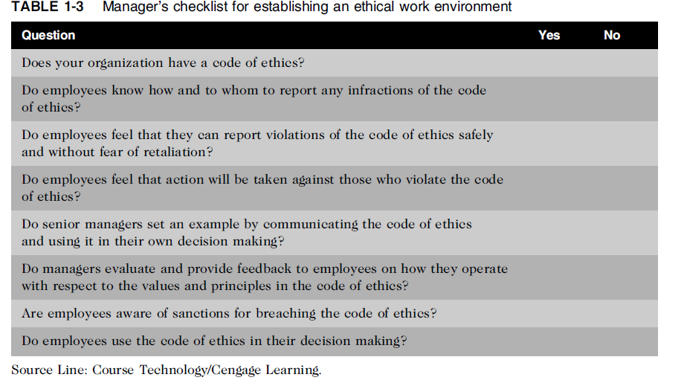
Including ethical considerations in decision making
- Steps in a decision-making process
  - Develop problem statement
  - Identify alternatives
  - Evaluate and choose alternative
  - Implement decision
  - Evaluate results
  - Success
Develop a Problem Statement
A problem statement is a clear, concise description of the issue that needs to be addressed. A good problem statement answers the following questions:
  - What causes people to think there is a problem?
  - Who is directly affected by the problem?
  - Is there anyone else affected?
  - How often does it occur?
  - What is the impact of the problem?
  - How serious is the problem?
The following list includes one example of a good problem statement as well as two examples of poor problem statements:
• Good problem statement: Our product supply organization is continually running out of stock of finished products, creating an out-of-stock situation on over 15 percent of our customer orders, resulting in over $300,000 in lost sales per month.
• Poor problem statement: We need to implement a new inventory control system. (This is a possible solution, not a problem statement.)
• Poor problem statement: We have a problem with finished product inventory. (This is not specific enough.)
Identify Alternatives
During this stage of decision making, it is ideal to enlist the help of others, including stakeholders, to identify several alternative solutions to the problem. Brainstorming with others will increase your chances of identifying a broad range of alternatives and determining the best solution. On the other hand, there may be times when it is inappropriate to involve others in solving a problem that you are not at liberty to discuss. In providing participants information about the problem to be solved, offer just the facts, without your opinion, so you don’t influence others to accept your solution. During any brainstorming process, try not to be critical of ideas, as any negative criticism will tend to shut down the discussion, and the flow of ideas will dry up. Simply write down the ideas as they are suggested.
Evaluate and Choose an Alternative
Once a set of alternatives has been identified, the group must evaluate them based on numerous criteria, such as effectiveness at addressing the issue, the extent of risk associated with each alternative, cost, and time to implement. An alternative that sounds attractive but that is not feasible will not help solve the problem. As part of the evaluation process, weigh various laws, guidelines, and principles that may apply.
Also consider the likely consequences of each alternative from several perspectives: What is the impact on you, your organization, other stakeholders (including your suppliers and customers), and the environment? The alternative selected should be ethically and legally defensible; be consistent with the organization’s policies and code of ethics; take into account the impact on others; and, of course, provide a good solution to the problem.
The alternative selected should be ethically and legally defensible; be consistent with the organization’s policies and code of ethics; take into account the impact on others; and, of course, provide a good solution to the problem. Philosophers have developed many approaches to aid in ethical decision making.
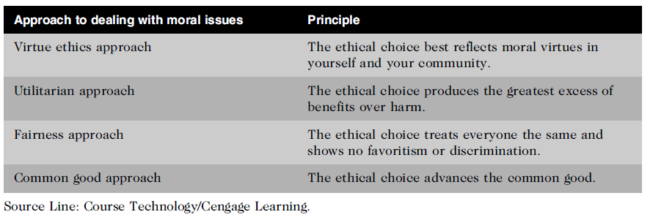

Reference
Lecture 02 slides: Introduction to ethics and their importance
Ethics in Information Technology, Reynolds, G., 6th Edition (2018), Cengage Course Technology.

